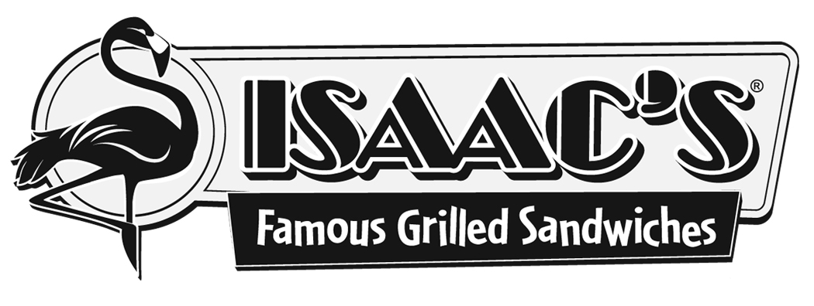JOIN US FOR OUR “COMMUNITY NIGHT” FUNDRAISER

On Sunday, June 12, 2011, Isaac’s Restaurant & Deli (Centerville) will be holding a “Community Night” fundraiser benefiting the Andreychek adoption from China. Enjoy an evening out with your family and friends while supporting our adoption of Le Le from China. Twenty-five percent (25%) of the cost of your meal will go directly to our adoption agency to pay for our adoption fees. Please come out and support us!

WHERE: Isaac’s Restaurant & Deli
Centerville (next to That Fish Place)
245 Centerville Road
Lancaster, PA 17603
(Valid at this location only)

WHEN: Sunday, June 12, 2011 5:00 – 9:00 p.m.

HOW: Bring this flyer with you to Isaac’s, complete the information, and hand it to the cashier when paying.

TAKEOUT: No time to sit down and eat? Call your order in ahead
of time to (717) 393-1199 and place a takeout order.

This form can be used for Dine-In, Takeout & Online Orders!
_________________________________________________
Please complete this information for your server.

Name:______________________________________________
Number of People in Party:_____________________________
Total Cost of Meal (excluding tax):________________________
*Coupons, discounts, or specials not valid during this fundraiser.

Thank you for partnering with Isaac’s and our adoption.

I want to receive Isaac's special offers and discounts by email. Email:____________________________________________________
JOIN US FOR OUR “COMMUNITY NIGHT” FUNDRAISER

On Sunday, June 12, 2011, Isaac’s Restaurant & Deli (Centerville) will be holding a “Community Night” fundraiser benefiting the Andreychek adoption from China. Enjoy an evening out with your family and friends while supporting our adoption of Le Le from China. Twenty-five percent (25%) of the cost of your meal will go directly to our adoption agency to pay for our adoption fees. Please come out and support us!

WHERE: Isaac’s Restaurant & Deli
Centerville (next to That Fish Place)
245 Centerville Road
Lancaster, PA 17603
(Valid at this location only)

WHEN: Sunday, June 12, 2011 5:00 – 9:00 p.m.

HOW: Bring this flyer with you to Isaac’s, complete the information, and hand it to the cashier when paying.

TAKEOUT: No time to sit down and eat? Call your order in ahead
of time to (717) 393-1199 and place a takeout order.

This form can be used for Dine-In, Takeout & Online Orders!
_________________________________________________
Please complete this information for your server.

Name:______________________________________________
Number of People in Party:_____________________________
Total Cost of Meal (excluding tax):________________________
*Coupons, discounts, or specials not valid during this fundraiser.

Thank you for partnering with Isaac’s and our adoption.

I want to receive Isaac's special offers and discounts by email. Email:____________________________________________________

